**CENWP-OD-B 08 August 2022**

**MEMORANDUM FOR THE RECORD**

**SUBJECT: 22BON076 MFR AFF Valve 15 Pacific Lamprey Mortalities**

On 08 August, Columbia River Inter-Tribal Fish Commission (CRITFC) Biologists notified Bonneville Project Biologists of two adult Pacific Lamprey mortalities found on the valve 15 trash rack in the Adult Fish Facility (AFF). The fish were scanned for PIT tags, inspected, and returned to the river.

1. Species – Pacific Lamprey (*Entosphenus tridentatus)*
2. Origin – Unknown
3. Length – Top fish: 70 cm, bottom fish: 60 cm
4. Marks and tags – None
5. Marks and Injuries found on carcass – N/A , very decayed
6. Cause and Time of Death – Unknown
7. Future and Preventative Measures – None

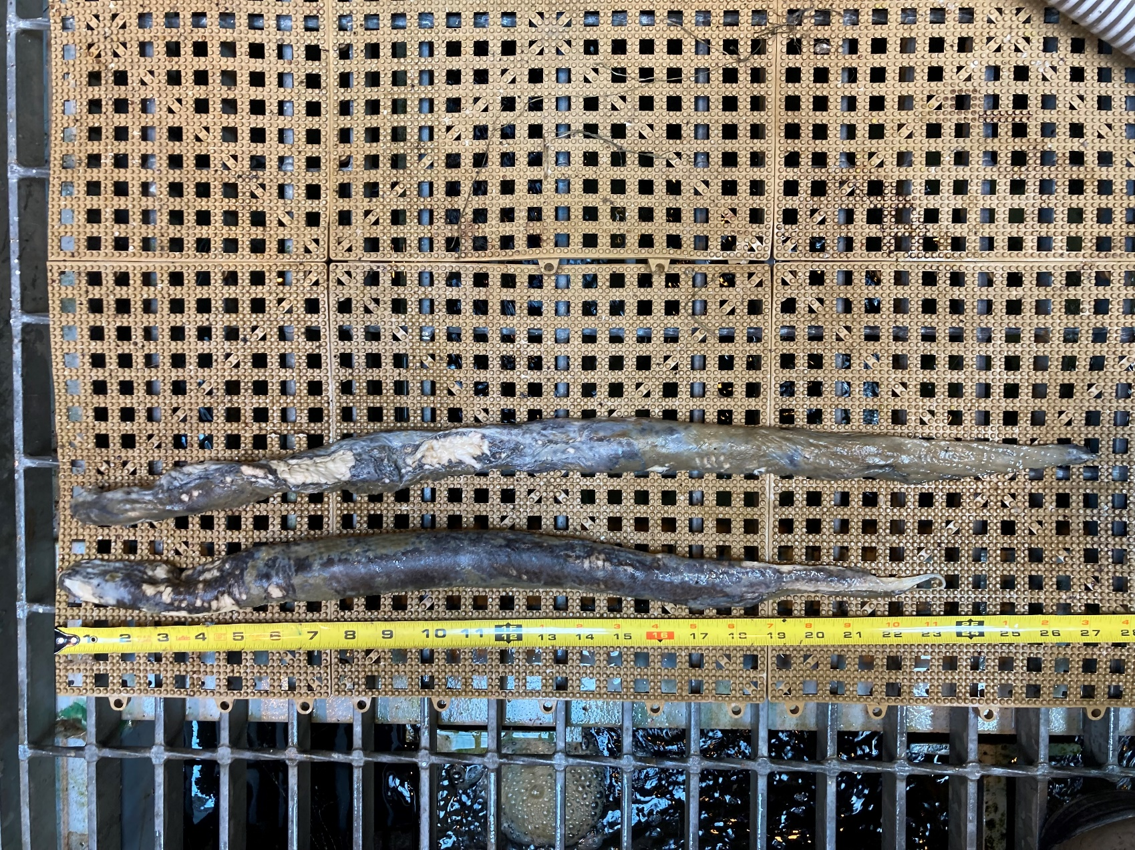

Sincerely,

Bonneville Project Fisheries